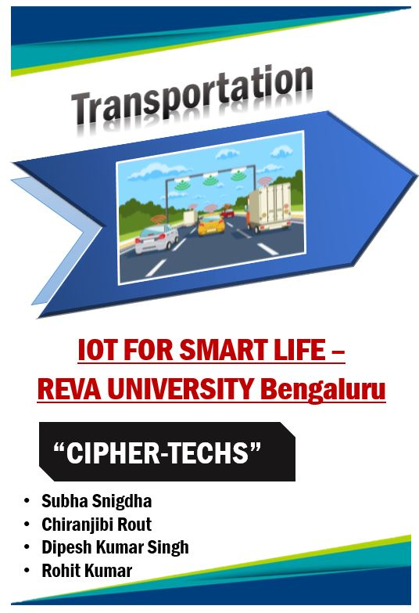

**Theme – “Transportation” :**

**Accident Alert System-***To predict and intimate the passengers of a vehicle in case of any possible accident.*

**Abstract:**

*In most of the cases after accident ,the probability of the survival of the driver is more, but due to delay in aid or information not received on time the person is deprived of his life.This project works upon the aftermath of accident so that immediate aid is provided to the victim.*

**Idea / Solution / Prototype**

*In the present scenario,major accidents occur due to the uneven interruptions. Globally, one life is claimed in a traffic accident every 25 seconds, Is there something which can be done to help the people and ensure road safety. YES, The answer is Internet of Things.*

*We aim to make a project which will detect the accident location and immediately send the location details to the guardian and nearest hospital so that instant action is taken to save the person’s life.*

*We aim to implement IOT on roads to make life much more better, safer and secure on Roads.*

**Hardware Requirements :**

* ***GSM Module*** *SIM 900 L*
* ***GPS Module*** *NEO 6MV*
* ***Accelerometer/Gyroscope MPU6050***
* ***Arduino Mega 2560***
* ***LCD display***

**Software Requirements:**

*The coding platform we have chosen is Arduino IDE,where the code is inserted into the*

*microcontroller and executed.*

**Objective :**

*Our project has the following objectives :*

* *To detect and report accidents that occur to the guardian,hospital and the police.*
* *To take instant action in case of any accident,after getting the notification*
* *To ensure the safety of people and minimize the accidents.*
* *To work for the betterment of the people and bring changes that are useful for everyone,by turning ideas into reality.*

**IDEATION / APPROACH DETAILS :**

* ***In this project, an IOT based vehicle accident detection and the rescue information system is developed in order to detect the vehicle accident and send the location data to vehicle owner,nearest hospital and police station.***

***Due to the lack of emergency facilities in our country, we are introducing the automatic alert device for vehicle accidents. The proposed system detects the accident and sends the information in less time to near-by first aid center.***

* **Accident Alert system using GPS,GSM and ACCELEROMETER**

Now a days many people die on the road due to accident, the main cause is "delay in rescue"

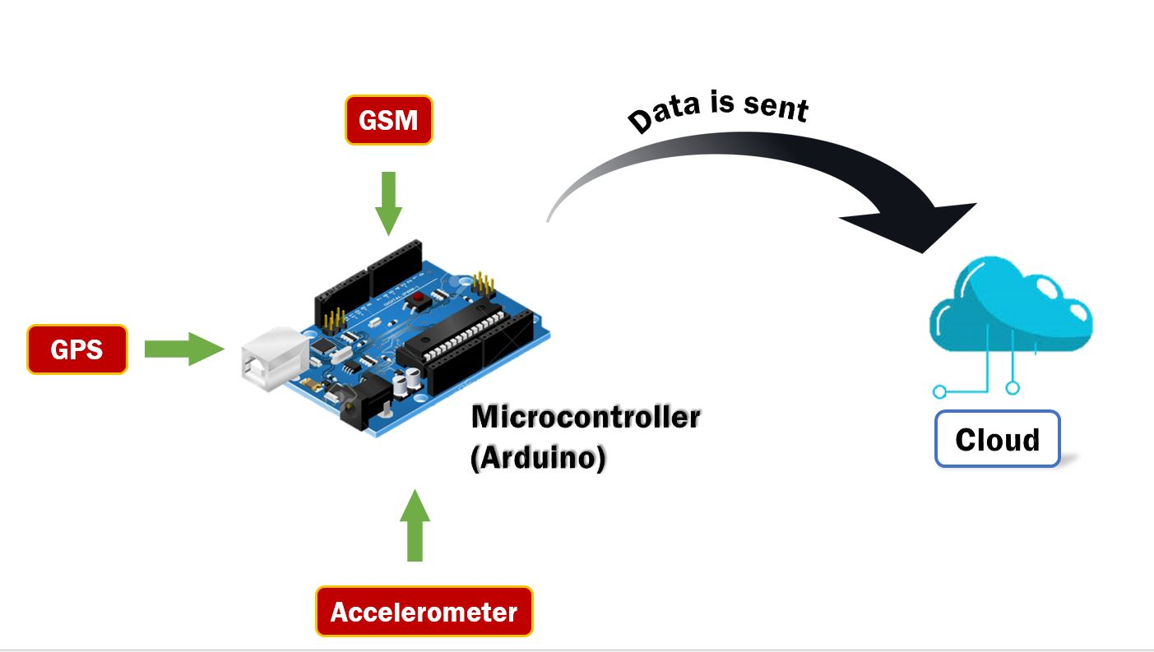

* In this project, Arduino is used for controlling the whole process with a **GPS Receiver and GSM module**.
* GPS Receiver is used for detecting coordinates of the vehicle, GSM module is used for sending the alert SMS with the coordinates and the link to the Google Map.
* **Accelerometer/ Gyroscope MPU6050** is used for stimulating accident or sudden change in any axis and the angle.
* Now whenever there is an accident, the car gets tilt and the gyroscope changes its axis values.
* The vehicle is provided with a button.If the button is pressed within 10 sec. then no message will be sent,since it is a minor one and no need to inform at home or the hospital. If the button is not pressed, then it implies a severe accident and action must be taken to save him/her.
* If any changes occurs then Arduino reads from GPS module data and sends SMS to the predefined number, to the police and hospital with the location coordinates of accident place.
* In case of any minor incident, the driver can himself handle at the situation and avoid the sending of details to the hospital or guardian by pressing the button.If the driver is not in a condition to press it within 10 sec. then only the details will be sent.
* The message also contains a Google Map link to the accident location, so that location can be easily tracked.

**Applications :**

* *Efficient use of data and sensors will help to manage traffic efficiently, regardless of the population surge*
* *The entire cause of accident i.e, the change of the axis,change in the angle and the rate of acceleration is entirely reported and gets recorded.*
* *Using the Arduino GPRS ,the Arduino Mega is converted to a HTTP web server,through which the data gets printed in the dashboard.*
* *We can also make use of Node MCU-ESP 8266 through which we can send the data to the cloud*
* *This product is applicable to advertise to the automobile companies so that they insert this system in their vehicles which acts effiiently to save the life of a person*

**Code :**

[**https://drive.google.com/file/d/17IuvPMYbIo15L6i3vSWIaIVbvbgshZBx/view?usp=sharing**](https://drive.google.com/file/d/17IuvPMYbIo15L6i3vSWIaIVbvbgshZBx/view?usp=sharing)

[**https://github.com/dipesh99kumar/Accident-Alert-System-GPS-GSM**](https://github.com/dipesh99kumar/Accident-Alert-System-GPS-GSM)